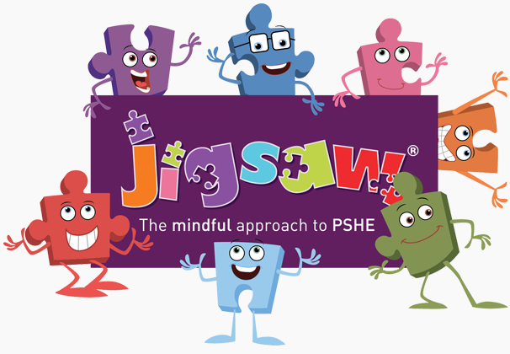


EYFS PSHE and PATHs Overview 2025/26
Jigsaw Resources Found: Jigsawpshe.online
PATHs Planning: PATHs Folder
Jigsaw 30 mins  PATHs 15 mins | Autumn 1   | Autumn 2   | Spring 1   | Spring 2   | Summer 1   | Summer 2  
Week 1 | Who…me?  Lesson 1: Circle Rules  Lesson 2: PATHS Animals | What am I good at?  Lesson 10: Angry 1  Lesson 10: Supplementary Activity | Challenge  Lesson 14: Twiggle learns to do turtle 1 | Everybody’s Body  Lesson 19 Calm or Relaxed | My Family and Me  Lesson 22 Twiggle Special Day | My Body  Lesson 26 Solving Problems
Week 2 | How am I feeling today?  Lesson 3: PATHS pupil of the day  Lesson 4: Compliments 1 | Im Special, Im me!  Lesson 11: Scared or Afraid  Lesson 11: Supplementary Activity | Never Giving Up  Lesson 14: Supplementary Activity | We Like to move it, Move it  Lesson 19: Supplementary Activity | Make Friends  Lesson 22 Supplementary Activity | Respecting My Body  Lesson 27 Solving problems with Friends
Week 3 | Being at School  Lesson 5: We all have feelings  Lesson 6 : Happy | Families  Lesson 12: My feelings  Lesson 12: Supplementary Activity | Setting a Goal  Lesson 15: Twiggle learns to do Turtle 2  Lesson 15: Supplementary Activity | Food Glorious Food  Emotion Sharing Session 3 | Falling Out and Bullying  Lesson 23 Advanced Compliments  Lesson 23 Supplementary Activity | Growing Up  Lesson 27 Supplementary Activity
Week 4 | Gentle Hands  Lesson 7: Sad  Lesson 8: Twiggle makes friends | Homes  Lesson 13: Angry 2 | Obstacles and Support  Lesson 16 Turtle Technique review | Sweet Dreams  Lesson 20 Sharing and Caring 1 | Being the Best Friends we can be  Lesson 24 Feelings Review  Lesson 24 Supplementary Activity | Fun and Fears  PATHs Party
Week 5 | Our Rights  Lesson 9: Compliments 2 | Making Friends  Lesson 13: Supplementary Activity | Flight to the Future  Lesson 16: Supplementary Activity | Keeping Clean  Lesson 20 Supplementary Activity | Unit 6 Lesson 25: Making choices | Celebration
Week 6 | Our Responsibilities  Emotion Sharing Session 1: Happy and Sad | Standing up for yourself  Emotion Sharing Session 2  Sharing Mad/Cross and Scared Feelings | Footprint Awards  Lesson 17 Appropriate Turtles 1  Lesson 18 Appropriate Turtles 2 | Safe Adults  Lesson 21 Sharing and Caring 2  Lesson 21 Supplementary Activity | Unit 6 Lesson 26: Solving problems
Books to Read | I love ME  The same but different  All are welcome | Meesha Makes Friends  Who are you?  Find your happy | Ravi’s roar  Ruby’s worry |  | Together we can  Super-duper you  A world for me and you | Tilda tries again  Colour monster  The friendship bench

