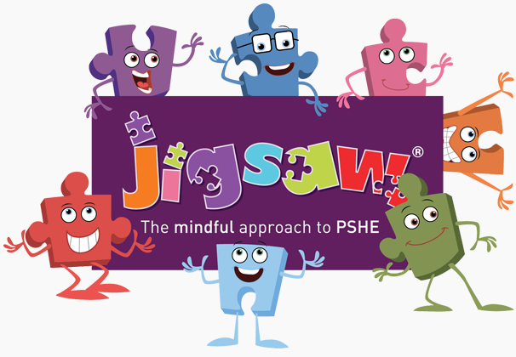


Year Five PSHE and PATHs Overview
Jigsaw Resources Found: Jigsawpshe.online
PATHs Planning: PATHs Folder
Jigsaw 30 mins  PATHs 30 mins | Autumn 1  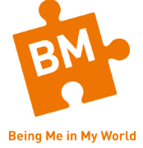 | Autumn 2   | Spring 1   | Spring 2   | Summer 1   | Summer 2  
Week 1 | My Year Ahead  Jumpstart Lesson 1 Classroom Rules: Mr Jones’ Class  Jumpstart Lesson 2 PATHS Pupil of the Day (Complimenting) | Different Cultures  Lesson 17 Setting Goals and Reaching Your Goal - Biography  Lesson 18 Setting a Goal: A Class Project To Improve the School | When I Grow Up  Lesson 25 The Eagles and the Championship Cup Final: Part 3  Lesson 26: Dealing With Teasing | Smoking  Lesson 34 Caring For Others - Dr Martin Luther King Jr Speech | Recognising Me | Self-Image and Body Image  Lesson 1 Control Signals Poster 1
Week 2 | Being a Citizen in my Country  Lesson 3 Co-operative Learning Skills  Lesson 4 The Golden Rule | Racism  Lesson 19: Setting a Goal and Making a Plan | Investigate Jobs and Careers  Lesson 27 Self-Concept - Our Feelings and Friendships  Lesson 28 Managing Our Feelings | Alcohol  Lesson 35 Authority I | Safety with Online Communities | Puberty for Girls  Lesson 2 Control Signals Poster 2
Week 3 | Responsibilities  Lesson 5 Introduction to Feelings – Feelings Poster  Lesson 6 Recognising and Controlling Anger – 3 Steps for Calming Down Poster | Rumours and Name-Calling  Lesson 20 Overcoming Obstacles - Biography of Jim Abbott | My Dream Job  Lesson 29: Forgiving and Resentful  Lesson 30 Dealing With Gossip | Emergency Aid  Lesson 36 Authority II | Being in an Online Community | Puberty for Boys
Week 4 | Rewards and Consequences  Lesson 7 Feelings Dictionary  Lesson 8 My Own Feelings Story | Types of Bullying  Lesson 21 Making New Friends | Dreams and Goals of Others  Lesson 31 Rejected and Excluded | Body Image  Lesson 37 Commemorating Others: The Titanic | Online Gaming | Conception  Lesson 40: PATHS Reactions and Review
Week 5 | Our Learning Charter  Lesson 9 Treasure Hunt: Problem-Solving Review  Lesson 10 Making Good Decisions - My Choice  Lesson 11: Identifying Problems - Feelings, Goals and Solutions | Does Money Matter?  Lesson 22 Joining In With Others | How Can We Support Each Other?  Lesson 32: Stereotypes and Discrimination | My Relationship with Food  Lesson 38 Honouring Others: Biography of Ray Davey | My Relationship with technology (Screen TIme) | Looking Ahead 1  Lesson 41: Planning a PATHS Party
Week 6 | Owning Our Learning Charter  Lesson 12 Consequences: What Might Happen Next?  Lesson 13 Making a Good Plan  Lesson 14 Trying Your Plan and Evaluating What Happens | Celebrating Difference Across the World  Lesson 23 The Eagles and the Championship Cup Final: Part 1  Lesson 24 The Eagles and the Championship Cup Final: Part 2 | Rallying Support  Lesson 33: Being Responsible and Creating Change - Biography | Healthy Meal  Lesson 39 Being Responsible: A Class Project | My Relationship ( Staying Safe and Happy Online | Looking Ahead 2  PATHS PARTY
Books to Read

