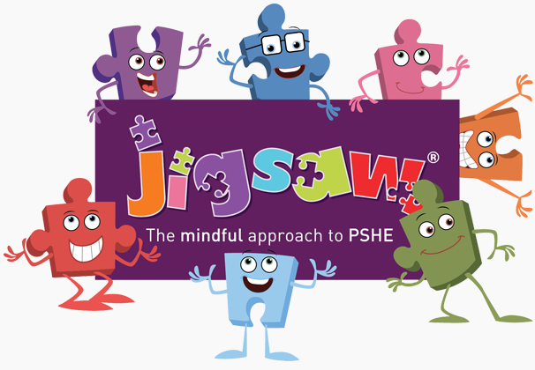


Year Four PSHE and PATHs Overview
Jigsaw Resources Found: Jigsawpshe.online
PATHs Planning: PATHs Folder
Jigsaw 30 mins  PATHs 30 mins | Autumn 1  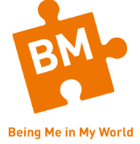 | Autumn 2   | Spring 1   | Spring 2   | Summer 1   | Summer 2  
Week 1 | Becoming a Class ‘Team’  Lesson 1: Classroom Rules: Mr Jones’ Class  Lesson 2: PATHS Pupil of the Day (Complimenting) | Judging by appearances  Lesson 17 Best Friends Story – Part 1  Lesson 18 Best Friends Story - Part 2 | Hopes and Dreams  Lesson 26: Being Responsible  Lesson 27: Being Responsible and Creating Change | My Friends and Me  Lesson 34: Setting Positive Goals  Lesson 35: Reaching A Goal | Jealousy | Unique Me  Lesson 1: Moody, Grumpy and Furious
Week 2 | Being a School Citizen  Lesson 3: Co-operative Learning Skills  Lesson 4: The Golden Rule  Lesson 5: Listening To Others | Understanding Influences  Lesson 19 Best Friends Story - Part 3  Lesson 20:Best Friends Story - Part 4: Making Up | Broken Dreams  Lesson 28: Social Responsibility – A Class Project | Group Dynamics  Lesson 36: Reaching Our Goals – Homework  Lesson 37: Generating Solutions 1 | Love and Loss | Having a Baby Alternative 2a  Lesson 2: Uneasy and Terrified
Week 3 | Rights, Responsibilities and Democracy  Lesson 5: Listening To Others  Lesson 6: Introduction to Feelings  Lesson 7: Recognising and Controlling Anger | Understanding Bullying  Lesson 21: Making Good Decisions 1- Deressa’s Choice  Lesson 22: Making Good Decisions 2 -Refusal Skills | Overcoming Disappointment  Lesson 29 Problem 1 – Identifying Problem | Smoking  Lesson 38: Generating Solutions 2 | Memories | Girls and Puberty  Lesson 3: A Little Down, Sad, Depressed
Week 4 | Rewards and consequences  Lesson 8: Control Signals Poster 1  Lesson 9: Control Signals Poster 2 | Problem Solving  Lesson 23: Making Good Decisions 3 -Loni’s Challenge  Lesson 24: Making Good Decisions 4 -Thinking Ahead | Creating New Dreams  Lesson 30 Problem 2 – Smart Vs Confused | Alcohol  Lesson 39: Thinking Takes Time | Getting on and Falling Out | Circles of Change  Lesson 41 PATHS Reactions and Review
Week 5 | Our Learning Charter  Lesson 10: PATHS Feelings Dictionary  Lesson 11: Feelings Intensity  Lesson 12: My Own Feelings Story | Special Me  Lesson 25: Making Good Decisions 5 - Alfie Learns a Lesson | Achieving Goals  Lesson 31 Problem 3 – Different Points Of View | Healthy Friendships  Lesson 40: Coping With Difficult Problems | Girlfriends and Boyfriends | Accepting Change  Lesson 42: Planning a PATHS Party
Week 6 | Owning our Learning  Lesson 13:Playing By the Rules  Lesson 14:Solving an Important Problem  Lesson 15: Avoiding Gossip |  | We did it!  Lesson 32 Problem I 4 – Why Things Happen  Lesson 33: Goals – Identifying Individual Goals | Celebrating My Inner Strength and Assertiveness | Celebrating My Relationships with People and Animals | Looking Ahead  PATHS PArty
Books to Read

