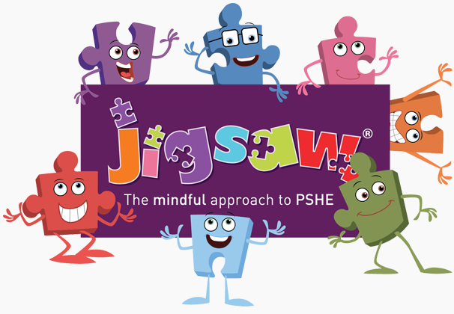


Year One PSHE and PATHs Overview 2025/26
Jigsaw Resources Found: Jigsawpshe.online
PATHs Planning: PATHs Folder
Jigsaw 30 mins  PATHs 15 mins | Autumn 1   | Autumn 2   | Spring 1   | Spring 2   | Summer 1   | Summer 2  
Week 1 | Special and Safe  Lesson 1: Circle Rules  Lesson 2: PATHS Animals  Lesson 3: PATHS pupil of the day | The Same As  Lesson 14 Twiggle learns to do turtle 1 | My Treasure Chest of Success  Lesson 22: Twiggle Special Day | Being Healthy  Lesson 30: Excited | Families  Lesson 36: Disappointed | Life Cycles
Week 2 | My Class  Lesson 4: Compliments  Lesson 5: We all have feelings | Different Form  Lesson 15: Twiggle learns to doTurtle 2 | Steps to Goals  Lesson 23: Advanced Compliments | Healthy Choices  Lesson 31: Tired | Making Friends  Lesson 37: Jealous | Changing Me  Lesson 41: PATHS Review
Week 3 | Rights and Responsibilities  Lesson 6: Happy  Lesson 7:Sad | What is Bullying?  Lesson 16: Turtle Technique review | Achieving Together  Lesson 24: Feelings Review | Clean and Healthy  Lesson 32: Frustrated | Greetings  Lesson 38: Furious | My Changing Body
Week 4 | Rewards and Feeling Proud  Lesson 8: Twiggle makes friends  Lesson 9: Compliments 2 | What do I do about Bullying?  Lesson 17: Appropriate Turtles 1  Lesson 18: Appropriate Turtles 2 | Stretchy Learning  Lesson 25: Making choices  Lesson 26: Solving problems | Medicine Safety  Lesson 33: Proud | People who Help Us  Lesson 39: Guilt | Boys and Girls Bodies  Lesson 42: Saying goodbye
Week 5 | Consequences  Emotion Sharing Session 1: Happy and Sad  Lesson 10 Angry 1  Lesson 11 Scared or Afraid | Making New Friends  Lesson 19: Calm or Relaxed  Emotion Sharing Session 3 | Overcoming Obstacles  Lesson 27: Solving problems with Friends | Road Safety  Lesson 34: Love | Being My Own Best Friend  Lesson 40: Generous | Learning and Growing  Lesson 43: Ending and transitioning
Week 6 | Owning our Learning Charter  Lesson 12 My feelings  Lesson 13 Angry 2 | Celebrating Difference  Celebrating me  Lesson 20: Sharing and Caring 1  Lesson 21: Sharing and Caring 2 | Celebrating My Success  Lesson 28: Comfortable and Uncomfortable  Lesson 29: Different Types of Feelings | Happy Healthy Me  Lesson 35: Worried | Celebrating My Special Relationship | Coping with Changes  PATHS PARTY!
Books to Read |  | Children of the world  Hats of faith  What makes me, me? |  |  | All are welcome here  Grandads camper  How to find a monster

