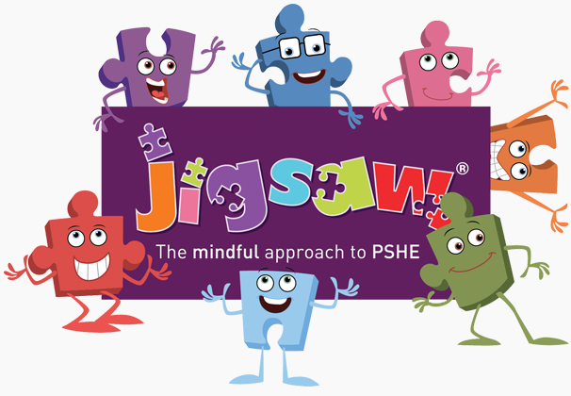
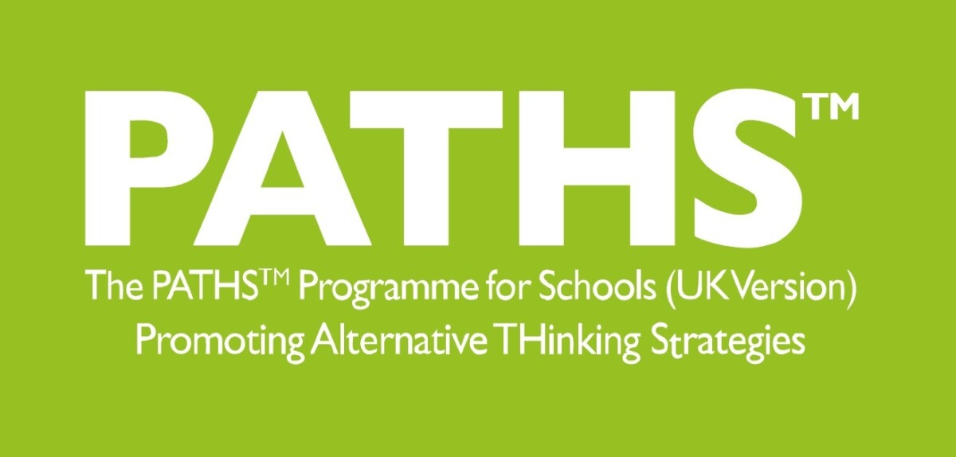

Year Six PSHE and PATHs Overview
Jigsaw Resources Found: Jigsawpshe.online
PATHs Planning: PATHs Folder
Jigsaw 30 mins  PATHs 30 mins | Autumn 1  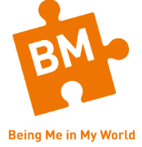 | Autumn 2   | Spring 1   | Spring 2  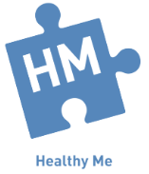 | Summer 1  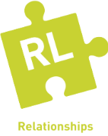 | Summer 2  
Week 1 | My Year Ahead  Lesson 1 Classroom Rules: Mr Jones’ Class  Lesson 2 PATHS Pupil of the Day (Complimenting) | Am I Normal?  Lesson 16 Conflict on the Court | Personal Learning Goals  Lesson 25 Number the Stars/Problem solving steps  Lesson 26 Our Presentation 1 | Taking Responsibilities  Lesson 26 Our Presentation 1 | What is Mental Health? | My Self-Image  Lesson 1 Control Signals Poster 1  Lesson 2 Control Signals Poster 2
Week 2 | Being a Global Citizen 1  Lesson 3: Reviewing the Problem-Solving Chart  Lesson 4 Learning a Way to Calm Down | Understanding Difference  Lesson 17 Conflict Resolution  Lesson 18 Resolving Conflict | Steps to Success  Lesson 27 Our Presentation 2  Lesson 21 What is respect? | Drugs  Lesson 27 Our Presentation 2 | My Mental Health | Puberty  Lesson 3 Problem-Solving Meeting  Lesson 4 Solving Problems – Dear Problem-Solvers
Week 3 | Being a Global Citizen 2  Lesson 5 More ways to Calm Down and Handle Stress  Lesson 6 Making Good Decisions  Lesson 7 Getting Help from Others | Power Struggles  Lesson 19 Stating the Problem  Lesson 20 Listening Thoughtfully | My Dreams for the World  Lesson 22 Respect in the Community | Exploitation | Love and Loss | Babies: Conception to Birth  Lesson 28 Looking Back, Looking Forward
Week 4 | The Learning Charter  Lesson 8 Study Skills- Part 1  Lesson 9 Study Skills- part 2 – H.E.Y  Lesson 10: Good Listening Skills | Why Bully?  Lesson 21 Number the Stars | Helping to Make a Difference  Lesson 23 Respecting musical differences in the world | Gangs | Power and Control | Boyfriends and Girlfriends  Lesson 29 Wall of Worries – Building a Foundation
Week 5 | Our Learning Charter  Lesson 11 Story – ‘Triple T’  Lesson 12:S.E.T  Lesson 13 Study Skills- Being Organised | Celebrating Difference  Lesson 22:Number the Stars | Helping to Make a Difference  Lesson 24 Respecting food differences in the world | Emotional and Mental Health | Being Online | Real Self and Ideal Self  PATHS Reactions and Review
Week 6 | Owning Our Learning Charter  Lesson 14 Planning Ahead- A Biography and Class Project  Lesson 15 What is Conflict? | Celebrating Difference  Lesson 23 Number the Stars  Lesson 24 Number the Stars | Recognising Our Achievements  Lesson 25 Respecting differences- clothes | Managing Stress and Pressure | Using Technology Responsibly | The Year Ahead  Planning a PATHS Party
Books to Read

