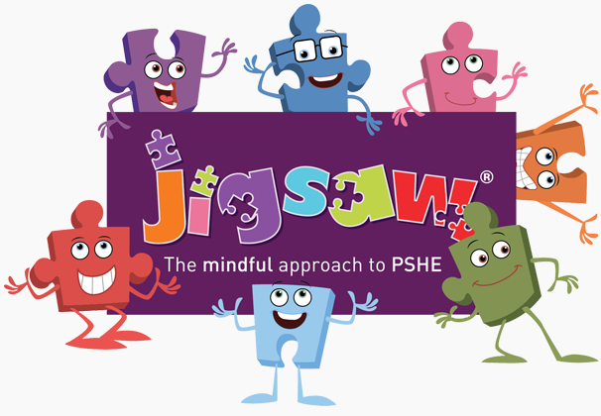
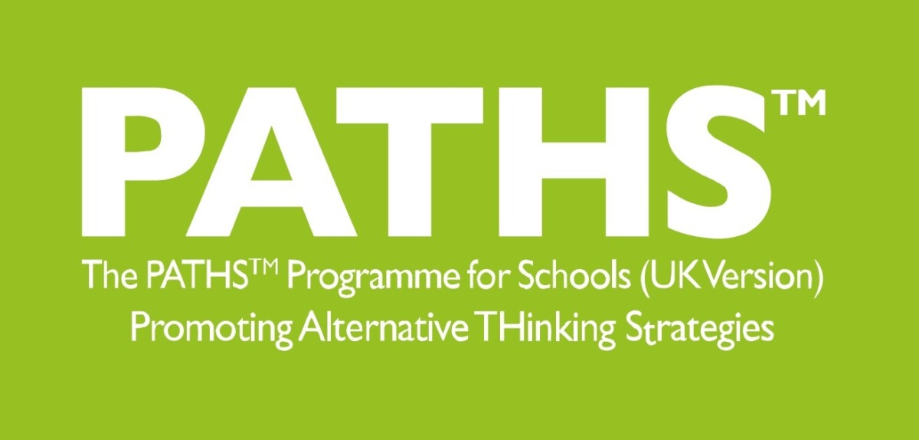

Year Three PSHE and PATHs Overview
Jigsaw Resources Found: Jigsawpshe.online
PATHs Planning: PATHs Folder
Jigsaw 30 mins  PATHs 2x 15 mins | Autumn 1  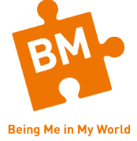 | Autumn 2   | Spring 1   | Spring 2  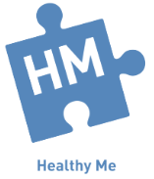 | Summer 1   | Summer 2  
Week 1 | Getting to Know Each Other  Lesson 1: Classroom Rules: Mr Jones’ Class  Lesson 2: PATHS Pupil of the Day (Complimenting) | Families  Lesson 14 Cross/Angry III (Baxter and His Temper) | Dreams and Goals  Lesson 22 Making Friends (Baxter Makes a New Friend) | Being Fit and Healthy  Lesson 32: Keeping a Friend (Baxter’s Challenge) | Family Roles and Responsibilities  Lesson 38: Fair/Not Fair | How Babies Grow  Lesson 45:PATHS Review Lesson 2
Week 2 | Our Nightmare School  Lesson 3: Introduction to Feelings – Happy, Sad and Private  Lesson 4: Fine, Excited and Tired | Family Conflict  Lesson 15: Making Good Choices | Dreams and Ambitions  Lesson 23 Frustrated  Lesson 24: Being a Good Winner/Loser | Being Fit and Healthy  Lesson 33: Making Up With Friends | Friendship  Lesson 39: Curious/Interested, Bored, Confused and Confident | Babies  Lesson 46:Planning a PATHS Party
Week 3 | Our Dream School  Lesson 5: Scared/Afraid and Safe  Lesson 6: Cross/Angry I | Witness and Feelings  Lesson 16: Problem-Solving Meeting I  Lesson 17: Problem-Solving Meeting II: School Transitions | A New Challenge  Lesson 25: Problem-Solving Meeting III – Friendship/Playtime  Lesson 26: Jealous and Content/Satisfied | What Do I Know About Drugs?  Lesson 34: Greedy/Selfish and Generous | Keeping Myself Safe Online  Lesson 40: Trying Harder/Overcoming Obstacles | Outside Body Changes
Week 4 | Rewards and Consequences  Lesson 7: Cross/ Angry II - Recognising Angry  Lesson 8: Calm, Relaxed and Worried | Witness and Solution  Lesson 18: Listening to Others | Our New Challenge  Lesson 27: Like/Love and Dislike/Hate and Tolerance  Lesson 28: Different Points Of View | Being Safe  Lesson 35: Surprised, Delighted and Disgusted | Being a Global Citizen 1  Lesson 41: Malicious and Kind | Inside Body Changes
Week 5 | Our Learning Charter  Lesson 9 PATHS Review Lesson I  Lesson 10: Self-Control I: Steps For Calming Down  Lesson 11: Self-Control II: Learning Self-Control | Words that Harm  Lesson 19: Fair Play Rules  Lesson 20 Introduction to Manners: Why Are They Important? | Our New Challenge  Lesson 29: Guilty  Lesson 30: Proud and Ashamed | Safe or Unsafe?  Lesson 36: By Accident, On Purpose | Being a Global Citizen 2  Lesson 42: Rejected and Included | Family Stereotypes
Week 6 | Owning Our Learning Charter  Lesson 12: Control Signals Poster I: Anger Management  Lesson 13 Control Signals II: Using the Control Signals Poster | Celebrating Difference  Lesson 21 Shy and Lonely | Celebrating My Learning  Lesson 31: Feelings Review 2: Guessing Game | My Amazing Body  Lesson 37: Disappointed and Hopeful | Celebrating My Web of Relationships  Lesson 43: Teasing  Lesson 44: Problem Solving Meeting IV: Bullying | Looking Ahead  Lesson 47: PATHS Party
Books to Read

