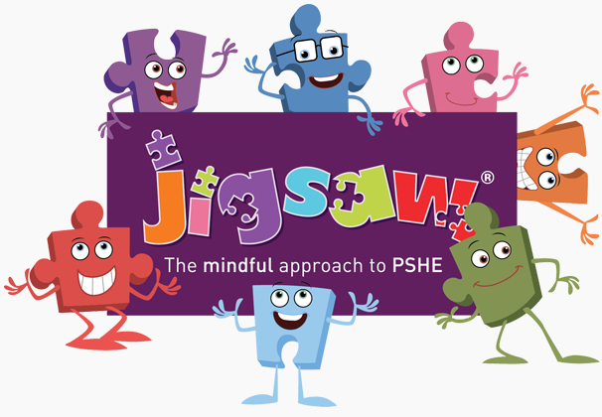


Year Two PSHE and PATHs Overview
Jigsaw Resources Found: Jigsawpshe.online
PATHs Planning: PATHs Folder
Jigsaw 30 mins  PATHs 2x 15 mins | Autumn 1  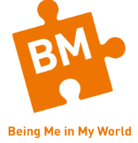 | Autumn 2   | Spring 1   | Spring 2   | Summer 1   | Summer 2  
Week 1 | Hopes and Fears for the Year  Lesson 1: Formulating Classroom Rules  Lesson 2: PATHS Readiness Lesson  Lesson 3: PATHS Pupil of the Day – Complimenting | Stereotypes  Lesson 15: Self-Control III | Goals to Success  Lesson 25 Making Friends | Being Healthy  Lesson 33: Manners 3  Lesson 34: Manners 4 | Families  Lesson 42: Frustrated | Life Cycles in Nature  Lesson 46: PATHS End of Year Review
Week 2 | RIghts and Responsibilities  Lesson 4: Introduction to Feelings  Lesson 5: Happy, Sad, Private | Stereotypes  Lesson 16: Calm or Relaxed and Relaxation Practice  Lesson 17: Control Signals Poster (Anger Management) | My Learning Strengths  Lesson 26: Shy  Lesson 27: Story/Activity on Shy and Problem-Solving Activity | Being Relaxed  Lesson 35: Fair Play Rules  Lesson 36: Listening To Others | Keeping Safe  Lesson 43: Hopeful, Disappointed | Growing from young to old  Lesson 47: Planning a PATHS Party
Week 3 | Rewards and Consequences  Lesson 6: Activities on Happy and Sad  Lesson 7: Fine, Excited, Tired | Why does Bullying Happen  Lesson 18: Problem Discussion – Angry Arthur  Lesson 19: Problem-Solving Meeting | Learning with Others  Lesson 28: Embarrassed  Lesson 29: PATHS Review Lesson | Medicine Safety  Lesson 37: Sharing  Lesson 38: Decision Wheel | Friends and Conflict  Lesson 44: Story/Activity on Hopeful | The Changing Me
Week 4 | Our Learning Charter  Lesson 8: Activities on Excited and Tired and A Review All Feelings  Lesson 9: Scared or Afraid, Safe  Lesson 10: Activities on Scared or Afraid and Safe | Standing up for myself and others  Lesson 20: Surprised, Expect  Lesson 21: Problem Discussion On Surprised | A group Challenge  Lesson 30: By Accident, On Purpose | Healthy Eating  Lesson 39: Curious, Interested, and Bored  Lesson 40: Proud, Ashamed | Secrets  Lesson 45: Problem Discussion on Frustrated or Disappointed | Boys and Girls Bodies  Lesson 47: Planning a PATHS Party
Week 5 | Owning Our Learning Charter  Lesson 11: Cross or Angry  Lesson 12: PATHS Review Lesson | Diversity  Lesson 22: Problem-Solving/ Privacy and Telling Your Feelings  Lesson 23: What Is a Good Friend? | Lesson 28: Embarrassed  Lesson 31: Manners 1  Lesson 32: Manners 2 | Healthy Eating  Lesson 41: Story/Activity on Proud | Trust and Appreciation | Assertiveness  PATHS PARTY
Week 6 | Following the Class Charter  Lesson 13: Self-Control I (Anger Management)  Lesson 14: Self-Control II (Anger Management) | Celebrating Difference  Lesson 24: Lonely | Celebrating our Achievements  Lesson 32: Manners 2 | Healthy, Happy Me | Celebrating My Special Relationships | Looking Ahead
Books to Read

