 | Autumn |  | Spring |  | Summer
EYFS | Pupils will build on previous experiences of number from their home and nursery environments, and further develop their subitising and counting skills. They will explore the composition of numbers within 5. They will begin to compare sets of objects and use the language of comparison.  Pupils will:  • identify when a set can be subitised and when counting is needed  • subitise different arrangements, both unstructured and structured, including using the Hungarian number frame  • make different arrangements of numbers within 5 and talk about what they can see, to develop their conceptual subitising skills  • spot smaller numbers ‘hiding’ inside larger numbers  Pupils will continue to develop their subitising and counting skills and explore the composition of numbers within and beyond 5.  They will begin to identify when two sets are equal or unequal and connect two equal groups to doubles. They will begin to connect quantities to numerals. Pupils will: • continue to develop their subitising skills for numbers within and beyond 5, and increasingly connect quantities to numerals • begin to identify missing parts for numbers within 5 • explore the structure of the numbers 6 and 7 as ‘5 and a bit’ and connect this to finger patterns and the Hungarian number frame • focus on equal and unequal groups when comparing numbers Pupils will consolidate their counting skills, counting to larger numbers and developing a wider range of counting strategies. They will secure knowledge of number facts through varied practice. Pupils will: • continue to develop their counting skills, counting larger sets as well as counting actions and sounds • explore a range of representations of numbers, including the 10-frame, and see how doubles can be arranged in a 10-frame • compare quantities and numbers, including sets of objects which have different attributes • continue to develop a sense of magnitude, e.g. knowing that 8 is quite a lot more than 2, but 4 is only a little bit more than 2 Public ncetm.org.uk | 2 • connect quantities and numbers to finger patterns and explore different ways of representing numbers on their fingers • hear and join in with the counting sequence, and connect this to the ‘staircase’ pattern of the counting numbers, seeing that each number is made of one more than the previous number • develop counting skills and knowledge, including: that the last number in the count tells us ‘how many’ (cardinality); to be accurate in counting, each thing must be counted once and once only and in any order; the need for 1:1 correspondence; understanding that anything can be counted, including actions and sounds • compare sets of objects by matching • begin to develop the language of ‘whole’ when talking about objects which have part |  | Pupils will continue to develop their subitising and counting skills and explore the composition of numbers within and beyond 5.  They will begin to identify when two sets are equal or unequal and connect two equal groups to doubles.  They will begin to connect quantities to numerals.  Pupils will:  • continue to develop their subitising skills for numbers within and beyond 5, and increasingly connect quantities to numerals  • begin to identify missing parts for numbers within 5  • explore the structure of the numbers 6 and 7 as ‘5 and a bit’ and connect this to finger patterns and the Hungarian number frame  • focus on equal and unequal groups when comparing numbers  understand that two equal groups can be called a ‘double’ and connect this to finger patterns  • sort odd and even numbers according to their ‘shape’  • continue to develop their understanding of the counting sequence and link cardinality and ordinality through the ‘staircase’ pattern  • order numbers and play track games  • join in with verbal counts beyond 20, hearing the repeated pattern within the counting numbers |  | Pupils will consolidate their counting skills, counting to larger numbers and developing a wider range of counting strategies. They will secure knowledge of number facts through varied practice.  Pupils will:  • continue to develop their counting skills, counting larger sets as well as counting actions and sounds  • explore a range of representations of numbers, including the 10-frame, and see how doubles can be arranged in a 10-frame • compare quantities and numbers, including sets of objects which have different attributes  • continue to develop a sense of magnitude, e.g. knowing that 8 is quite a lot more than 2, but 4 is only a little bit more than 2 begin to generalise about ‘one more than’ and ‘one less than’ numbers within 10  • continue to identify when sets can be subitised and when counting is necessary  • develop conceptual subitising skills including when using a rekenrek
Year 1 | 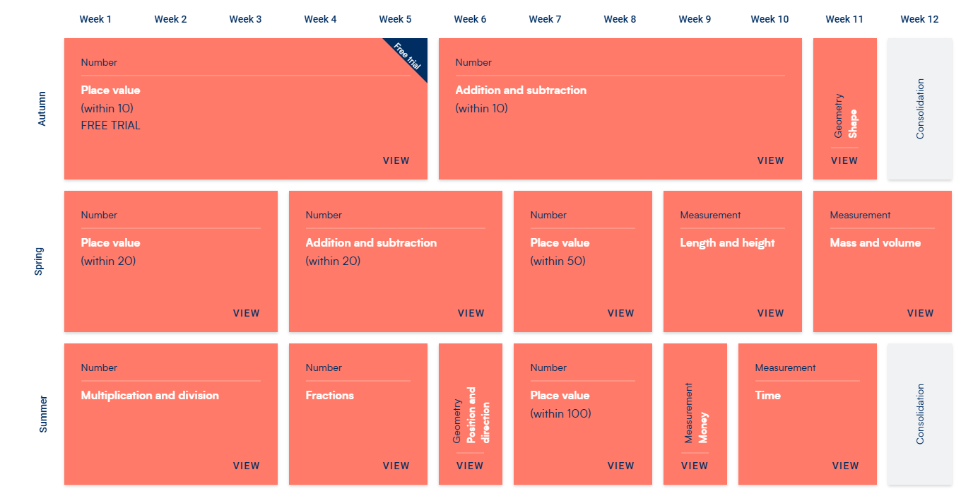
Year 2 | 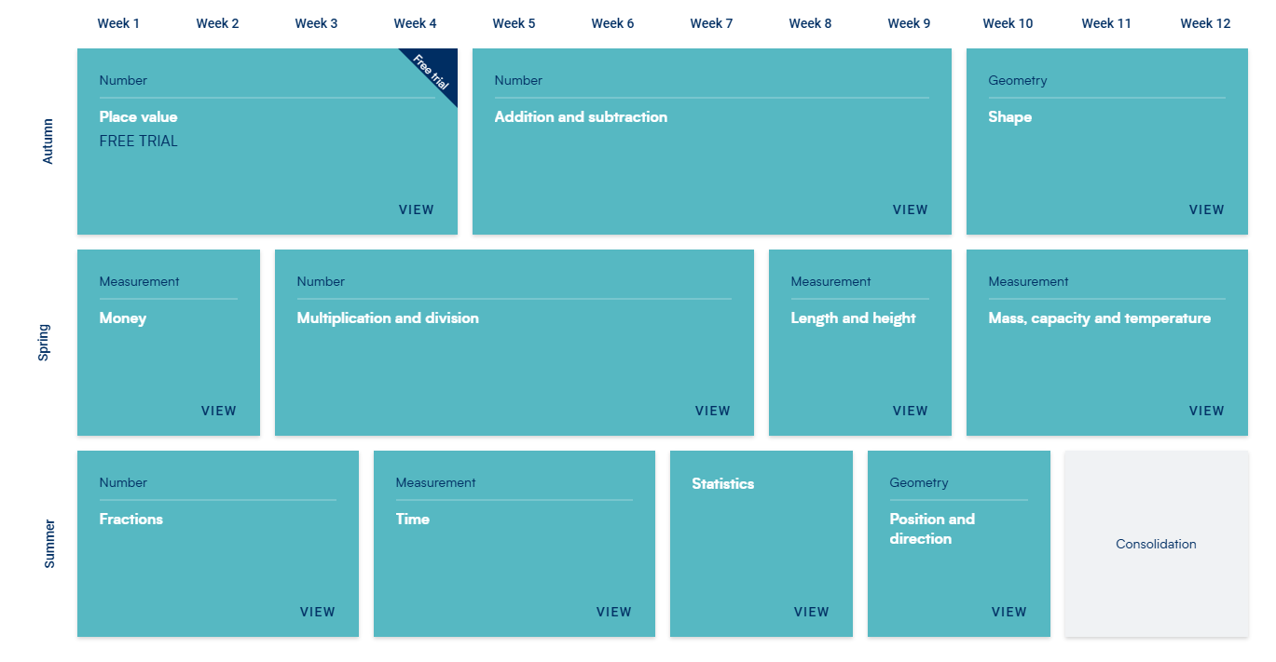
Year 3 | 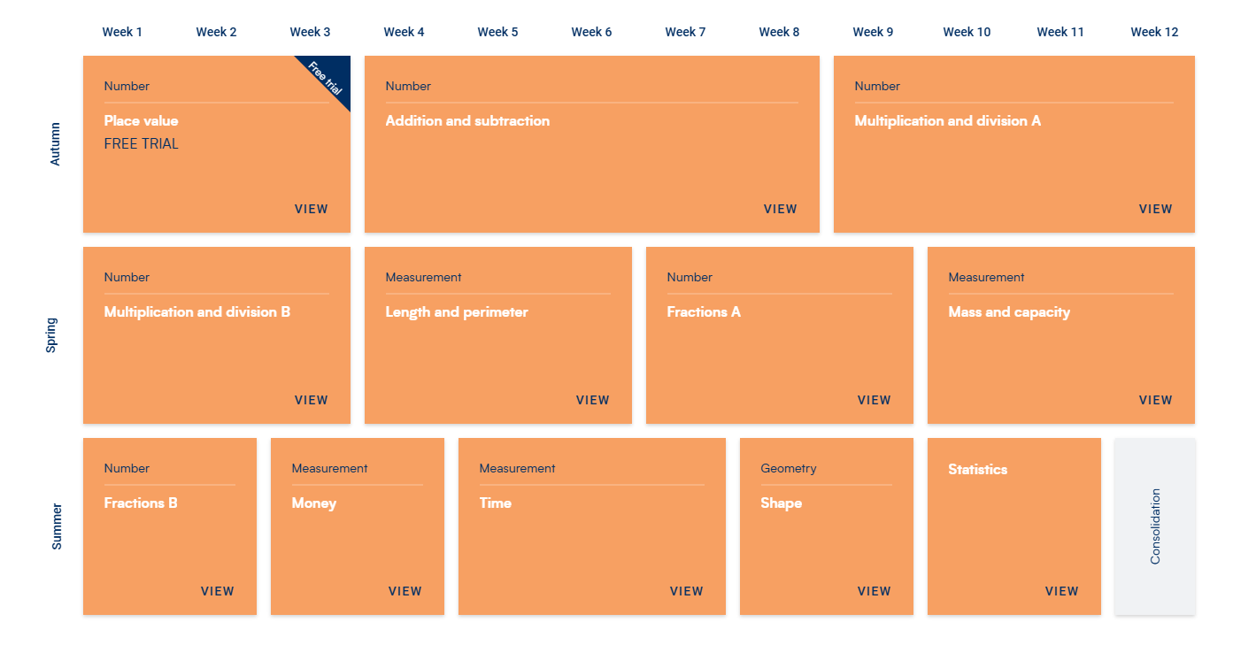
Year 4 | 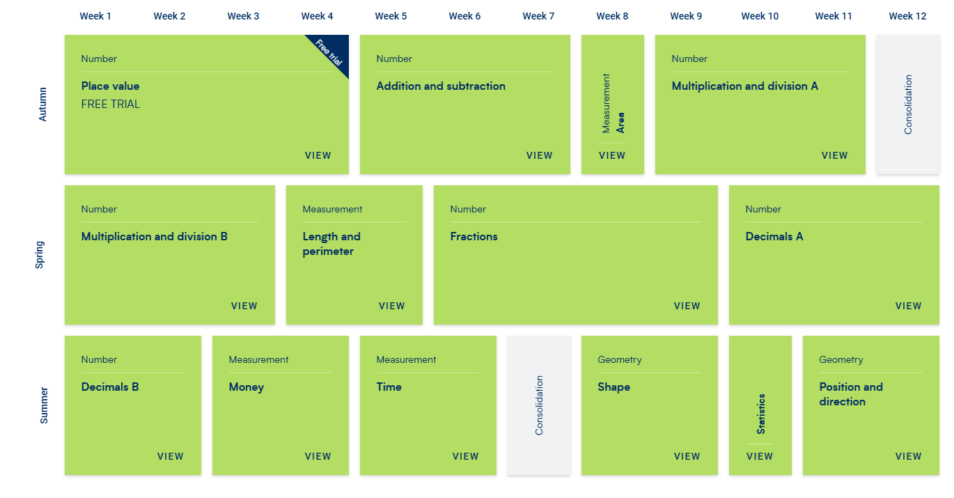
Year 5 | 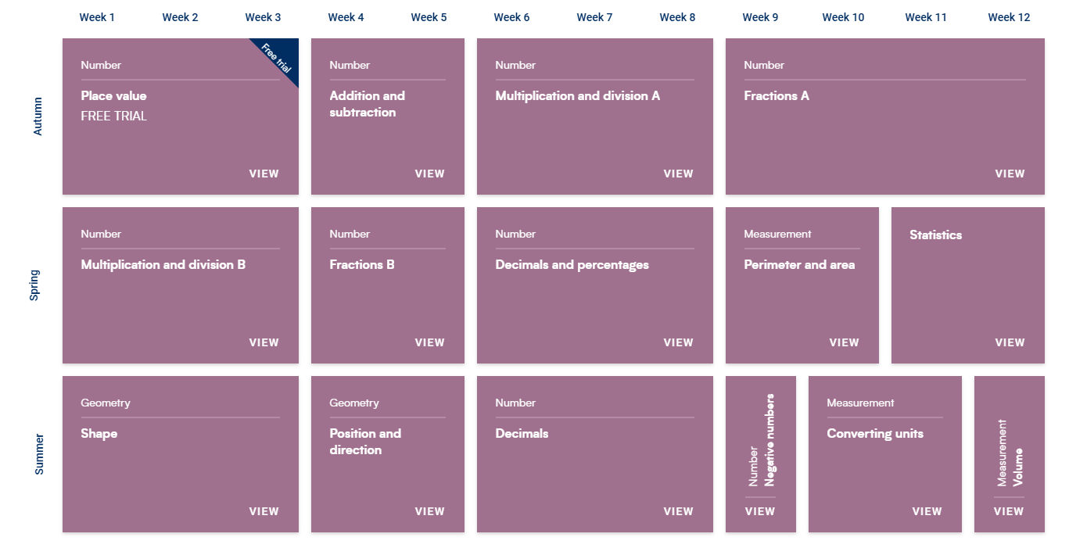
Year 6 | 

