

Griffin Primary School
SEND Information Report 2025-26

Griffin Primary School is committed to providing a high quality of education to all students. We believe that all students, including those identified as having special educational needs, are entitled to a broad, balanced and engaging academic and social curriculum, which is made accessible to all. At Griffin Primary we deliver a highly engaging and creative curriculum which aims to allow children to gain knowledge and develop skills.
- This does not mean that we will treat all learners in the same way, but that we will respond to learners in ways which take account of their varied life experiences and needs.
- We offer inclusive teaching which will enable all students to make the best possible progress in school and for them to feel that they are a valued member of the wider school community.
- The school looks carefully at each individual child’s needs when deciding how best to support them.

We comply with the Government’s Special Educational Needs and Disability Code of Practice 2014. The Code of Practice outlines the key ways students should be supported in class, along with expected equality duties shown in the SEND and Inclusion Policy 2025-26

Special Educational Needs and Disability Code of Practice 2014:

Special educational needs and provision can be considered as falling under four broad areas:

• Communication and interaction,
• Cognition and learning,
• Social, emotional and mental health
• Sensory and physical needs.

A child of compulsory school age or a young person has a learning difficulty or disability if she or he:

• has a significantly greater difficulty in learning than the majority of others of the same age, or
• has a disability which prevents or hinders her or him from making use of facilities of a kind generally provided for others of the same age in mainstream schools

Information and Guidance
Who should I contact to discuss the concerns or needs of my child?
Role | Responsibilities:
Class teacher and support staff  If you have concerns about your child, you should speak to your child’s class teacher first. | - Adapting and refining the curriculum to respond to the strengths and needs of all students.  - Checking on the progress of your child, identifying, planning and delivery of any additional support.  - Contributing to devising personalised learning plans e.g. SEND support plans, to prioritise and focus on the next steps required for your child to make progress academically and socially.  - Applying and adhering to the school’s SEND policy.  - Liaising and developing positive working relationships with parents/ carers and professionals in order to work in the best interest of the child
SENCO:  Miss Sheri Cooper  Email address:  scooper@griffinprimary.org  Phone: 0207 622 5087 | - Coordinating effective and quality provision for students with SEND and developing and following the school’s SEND policy  - Liaising with a range of agencies outside of school who can offer advice and support to help students overcome any difficulties  - Making referral to external services where appropriate and in discussion with parents/carers  - Applying for Educational Health Care Plans where appropriate and in discussion with parents/carers  - Providing specialist advice and facilitating training to ensure that all staff are skilled and confident about meeting a range of needs.  - Ensuring that parents/ carers are:  - Involved in supporting their child’s learning and access to the curriculum  - Kept informed about the range and level of support offered to their child  - Included in reviewing how their child is doing;  - Consulted about planning successful movement (transition) to a new class or school.
Designated Safeguarding Leads  Mr Jack Taylor  Miss Rachel Robson  Miss Sheri Cooper | - The Designated Safeguarding lead at Griffin Primary is Jack Taylor, Deputy DSLs are Rachel Robson and Sheri Cooper. They are responsible for all Child Protection Concerns.  - Supporting students and their families in many varied ways; including meeting with families to offer information and advice around concerns around school, attendance issues, behaviour concerns, or any other issues.  - Can offer support and guidance regarding benefits, housing or worries that may have an impact on families
Principal  Jack Taylor  Vice Principal  Rachel Robson | - The day to day management of all aspects of the school, including the provision made for students with SEND and the safeguarding of students.
How does the school decide whether a child/young person has special education needs and what extra help they need?
If a member of staff has concerns regarding a child’s development in anyway and they believe that there may be additional underlying needs that may be affecting the development of the child that have not yet been identified, then they will adhere to the following process:
- Raise concerns with the Senco and complete an initial concerns form
- The Senco will then follow up with observations, book looks and discussions in order to triangulate information regarding the child
- The Senco will make some key recommendations for the class teacher to use in order to support the child and monitor the progress
- It may be that the child, with the right adaptations, will make the progress required and will not be placed on the SEND register.
- However, if the progress is not evident or the needs are significant, external advice may be required to ascertain whether there are additional underlying needs.
- At all points of this process, parents/ carers will be informed and invited to informal meetings, as well as professional meetings e.g. TAC meetings and their views will be sought and welcomed
- If all professionals are in agreement, then the child will be placed on the SEND register and additional support/ provision will be put into place and reviewed regularly (See below for SEND support)

The Graduated Approach: How can I find out about how well my child is doing?
This is how we monitor students’s progress as a school:
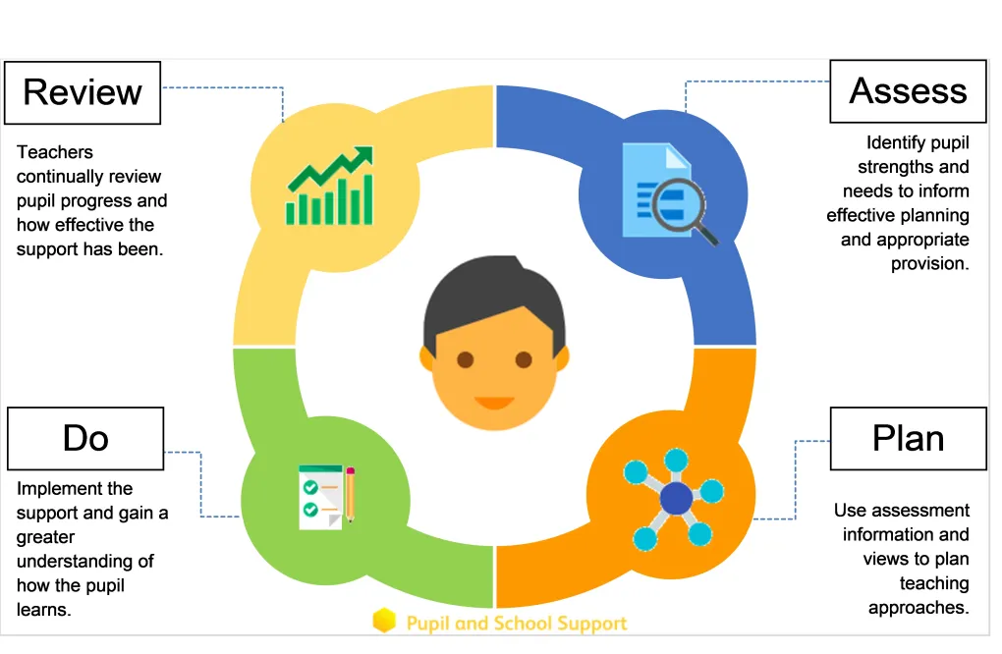

- This will be communicated by a child’s termly SEND support plan, during informal meetings and professional meetings, parent/ carer evenings and annual reviews (if a child has an Education Health and Care plan)
- A SEND support plan identifies the needs of the child, what additional provision they are accessing, external agency involvement and around 3 SMART (Specific, Measurable, Achievable, Realistic and Timely) targets, set and reviewed by the class teacher, in collaboration with the Senco and any external agencies involved
- If a child has a specific need e.g. a speech and language need, a referral may be made to the relevant agency once parents/carers have consented. Following appropriate assessments, a programme of support is usually provided to the school and shared with the parents/carers and this will be reflected in the SEND support plan
- Additional funding is available for students who meet the criteria for an Educational Health Care Plan. This can be accessed using the Local Authority process and guidance in the banded funding criteria. Further details about this process will be explained in the LA Local Offer.
If you are a Wandsworth resident please refer to the Wandsworth Family Information Service website found through this link: Wandsworth Local Offer
If you are a Lambeth resident please refer to the Lambeth Information Service website found through this link: Lambeth Local Offer

Partnerships with External Agencies What support from outside does the school use to support my child?
Agency | Description of support
Educational Psychology Service | The EP assigned to the school is Iesha Ginn
School Nurse | Students are referred to the school service or parents/ carers can request involvement
Speech & Language Therapy Service | The Wandsworth SaLT therapist is Robyn Everett  The Lambeth SaLT therapist is Emma Morris  Students are referred to this service following concerns raised by parents/staff or through the Wellcom Screener which takes place in EYFS
Victoria Drive Pupil Referral Unit Headteacher | Supporting children with SEMH needs or MLD
Wandsworth ASD Advisory Service (WAAS) | Students are referred to this service as needed
Occupational Therapy / Physiotherapy | Students are referred to this service as needed
CAMHS (Child & Adolescent Mental Health Services) and Under 5 CAMHs | Students are referred to this service as needed
Paediatric services | Students are referred to this service as needed
Wandsworth Hearing Impaired Support Service | Students are referred to this service as needed
Wandsworth Visually Impaired Support Service | Students are referred to this service as needed
Virtual School (students Looked After Education Support Service) | The role of the team is to raise educational attainment and offer targeted support to students looked after by the council.
Unlocking Potential Service | Therapy Team Manager is Miriam Catley

Transition How will the school help my child move to a new year group or to a different school?
When moving to another school:
- We will contact the School SENCO and share information about special arrangements and support that has been made to help your child achieve their learning goals.
- Individual arrangements may be made to visit the new school with support staff.
- We will ensure that all records are passed on as soon as possible.
When moving classes in school:
- An information sharing meeting will take place with the new teacher.
- Opportunities to visit the new class / teacher and a transition morning will take place
Transition to secondary school
- The SENCO will attend the Wandsworth Primary/Secondary Transition day meeting to discuss specific needs of your child and the nature and level of support which has had the most impact.
- In some cases a more detailed transition plan may be needed which may include additional visits to the new school and/or additional visits from the new school.
- The SENCO from the secondary school is invited to attend the annual review (if held in the summer term) or any other relevant meetings.

Staffing Expertise
How skilled are staff in meeting the needs of my child?
An ongoing programme of training is in place to ensure that teachers and support staff have the appropriate skills and knowledge in areas that will improve their teaching and support of students with SEND.
Recent training has covered or will cover:
- Speech & Language development – key adults (teaching assistants or teachers) working with individual students meet the Therapist termly. Most recent training included Blank Level Questions and Colourful Semantics
- Teaching and support staff have received training on supporting early communication and sensory processing
- SENCO has achieved the NASENCO Award in 2021
- SENCO attends termly Wandsworth SENCO forums
- Trauma Informed practice modules and Positive Handling training
The SENCO actively engages with local opportunities to share best practice and keep abreast of current local and national initiatives and policy to support students with SEND.
The school will seek advice and guidance from local special schools to review, evaluate and develop provision for students who have the most complex needs.

Who do I talk to if I am unhappy with my child’s support or progress?
Class teacher

SENCO

Deputy Headteacher

Executive Headteacher

Where can I go for further advice and support?
- Wandsworth Information Advice and Support Service (WIASS) provides an impartial, free and confidential service to all parents of children with SEND and young people with SEND. You can email wiass@wandsworth.gov.uk or telephone 020 8871 8065 (24 hour confidential answer machine or 020 8871 5237, term time only, Monday 10am to 1pm, Wednesday 1.30pm to 4.30pm or Friday 10am to 1pm.
- The SEND parent carers group works with the Council to improve all provision for children and young people with SEN and Disabilities aged 0 to 25. If you want to get involved in influencing services visit the https://sites.google.com/sendpcwandsworth.org.uk/helpcentre
website
- More information about Wandsworth’s SEND local offer of services and support for children and young people with special needs and disabilities in Wandsworth can be found on the Wandsworth Local Offer website. THRIVE Wandsworth’s helpline is open from 9am to 5pm, Monday to Friday on 020 8871 7899. Or email thrivewandsworth@richmondandwandsworth.gov.uk
- If you are a Lambeth resident you can access the Lambeth Local offer. The Lambeth Information and Advice support service (LIASS) provides an impartial, free and confidential service to all parents of children with SEND and young people with SEND.

